JAMES K. GALBRAITH IN BESANCON MAY 18-19 2009
(Report* by Daniel Pichoud)



James Galbraith with Alain Parguez at the top of the Besançon Citadel( Fortifications of Vauban UNESCO’s World Heritage list)
Photo Daniel Pichoud

Responding to the invitation of Alain Parguez, James K Galbraith (Lloyd M. Bentsen Jr. Chair in Government/Business Relations and Professor of Government ; University of Texas at Austin) gave a lecture at the University of Besançon on ‘The new New Deal of President Obama”
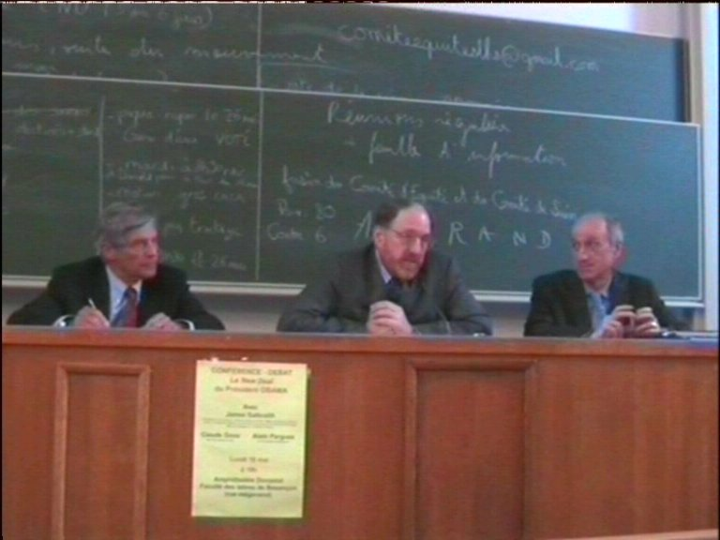
James K. Galbraith was introduced by Alain Parguez as one of the most listened to American economists and a “true liberal”
After saying that the main reason of his being in Besançon was to pay homage to his friend Alain Parguez who he considers as one of the more lucid monetary economist today, James Galbraith in a presentation given entirely in French underscored that the present world crisis is also a crisis of the economic thought and that it is not a simple “failure of the markets” as suggested by neoclassical economists.

There follows a short summary of the lecture:
Since the New Deal of President Roosevelt (March 1933) the USA are no more a Market Economy. Even the Reagan revolution of 1981-1983 did not change anything.
What caused the 2007-2008 crisis in the USA was the subversion of the State by the Bush administration (described in James Galbraith’s book “The Predator State” Free Press 2008). Deregulation (abrogation in 1999 of the Glass-Steagall banking act of 1933) was at the origin of the crisis.
In Europe the crisis is a crisis of governance, the economic union is weak. The central bank contrary to the US Fed is only acting to stem inflation and has no means to fight the crisis.
In the USA Keynesian automatic stabilizers are at work; nobody is willing to limit the budget deficit in such circumstances. In September 2008 this deficit reached 8% of GNP ( G.W Bush was still there) with tax cuts and public spending and that stimulus is beginning to be effective. On the other hand the bail out plan for the banks is a disaster; the big banks are saved from failure without any counterpart.
There is a risk to believe that the financial crisis is over and to stop the budgetary policy of growth when much more is needed (a consensus is not yet obtained in the USA on the following):
-Increase social security benefits that guarantee a minimum income to the elder and the unemployed.
-Allow the States of the Union to borrow massively to overcome their budgetary crisis.
- Initiate a public works program like the Roosevelt one that created 3 millions jobs to build roads, schools, airports, dams and the aircraft carriers that won the war.
-Public Spending to solve the Energy (reduced oil supply) and environmental (Climate change) issues.
- Enable the government to regulate the financial sector. It is absolutely necessary that the State controls markets that are very complicated, technical and difficult to understand by investors. Without control fraud appears and it is the end of markets by default of confidence. We are now well aware that the stability of capitalism is an illusion and that a democratic control of Finance is needed.

James Galbraith then debated with Alain Parguez and Claude Gnos (University of Dijon) and with the large audience that attended the meeting.

Some of the Questions and Answers:

Wages and inequalities in the USA and in Europe?
The USA have less inequality in wages but a larger inequality in income because higher incomes are linked to the behaviour of he stock-exchange. Besides there is the fraud by managers of large companies, banks and financial institutions(looting) leading to unjustified compensations for some managers; a criminology is developing in the USA on this subject.
The worst mistake (it is well known since Keynes) is to think that to decrease real wages will reduce unemployment.

China?
It is false to say that China depends on the USA; it exports to acquire technologies and improve its quality control for the benefit of its own economy. The case of China is very important to explain the relationship between unemployment and inequalities; they are twin phenomenons. More unemployment leads to a reduction of real wages and more inequalities.
The Chinese threat is a myth. China has to export to improve its technology and will never use its huge reserves in dollars that are only figures in computers. The US administration is not at all afraid for the dollar.

Is there a risk that the Obama administration change its policy course?
There is no fear for the dollar at the present time. The Fed has even recently swapped 600 billions Euros for Dollars that were needed by the BCE to save European banks heavily indebted in dollars.
President Obama has accepted the plan for the banks to avoid a collapse of the financial system. But Social Security benefits will be increased because it has a strong impact on households income. Public spending (Federal and States of the Union) will be increased.
There is always a risk as said earlier. To change course would allow the crisis to come back.

A new Bretton Woods?
A new Bretton Woods doesn’t seem feasible on the short term even within the frame of the G20. The IMF has failed and a new system is necessary but it will take time.

On May 19 James Galbraith in company of Alain Parguez was interviewed by the leading newspaper in Besançon “L’Est Républicain” and an article was published in the edition of May 20th.
Quotation: “Even if Obama has not yet succeeded, James Galbraith is much more worried for the European Union which he considers very vulnerable, due to a choice of its political elites, the choice of ineffective governance from the macroeconomic point of view resulting also from a lack of solidarity between member States.
Alain Parguez is exactly on the same wavelength Against the crisis, Gordon Brown in Great Britain do not fear a budget deficit contrary to the countries of the Euro zone, the only region of the world were political leaders still believe to the virtue of reducing public deficits.”

Following the interview James Galbraith gave a lecture to the students of Alain Parguez in his course on Public Finance.

*This report has been approved by Professors James Galbraith and Alain Parguez

